**CHAPTER 4**

**SNAPSHOTS**

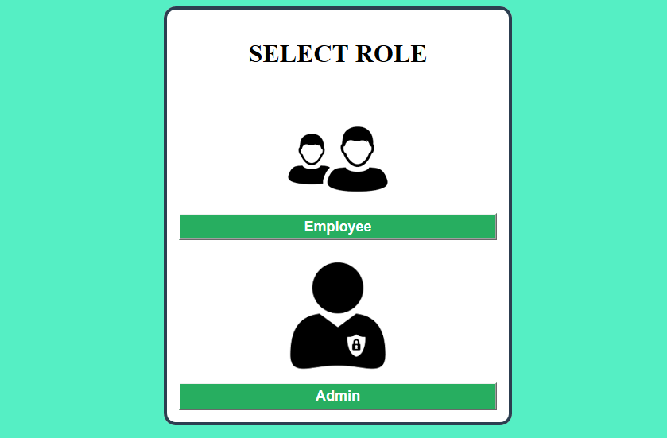

**Fig 4.1: HOME PAGE**

The above figure shows home page, where admin login and employee login is present.Admin login is used for company maintenance and employment login is used for employee purpose. Employee should employee login that button will take to next page. If employee is not registered employee then employee can sign up then login. If employee is registered student then can directly login.

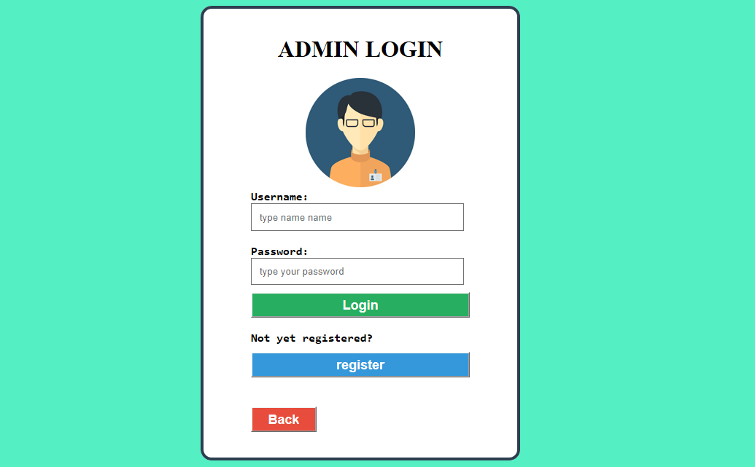

**Fig 4.2: ADMIN LOGIN PAGE**

The above figure shows admin login. Here admin insert username and password to login.

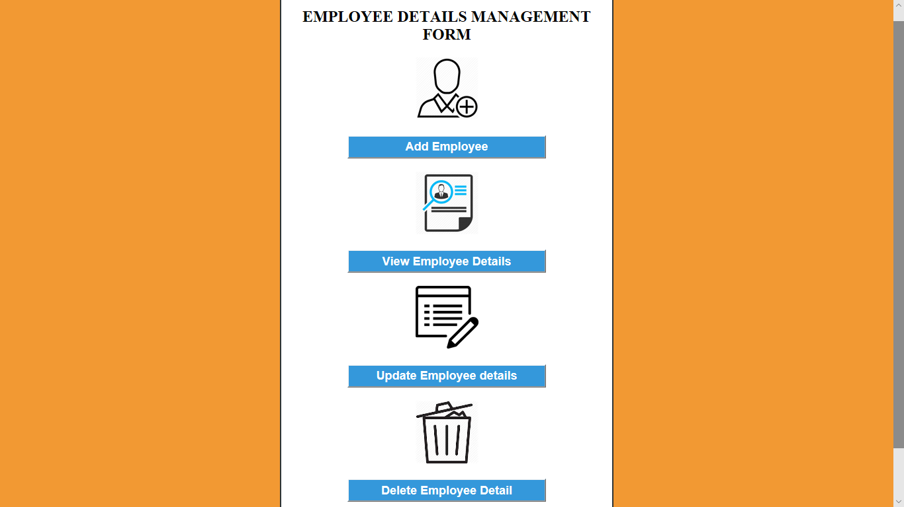

**Fig 4.3: ADMIN WORKSPACE PAGE**

The above figure shows admin workspace page. Here we have four buttons i.e add employee is used to add the employee details. View employee is used to retrieve the employee details. Update employee is used to edit the details. Delete employee is used to delete the details.

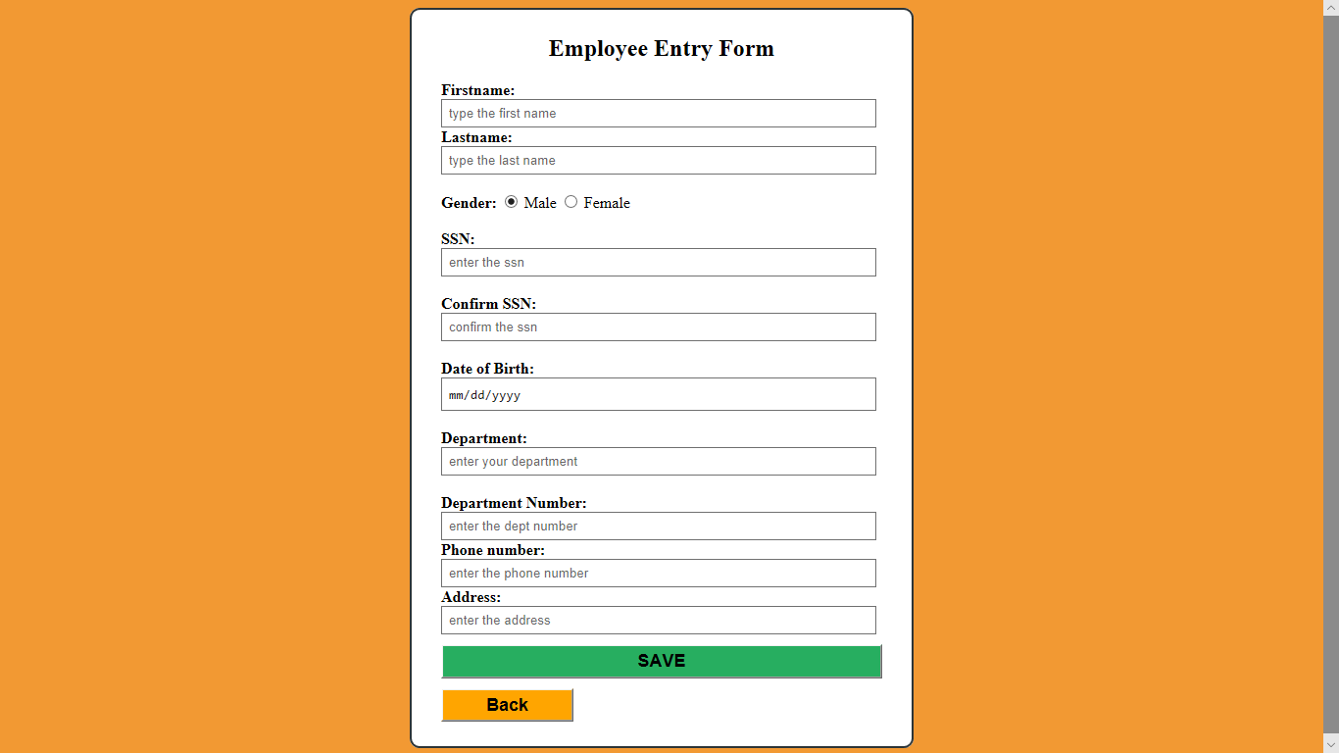

**Fig 4.4: EMPLOYEE ENTRY PAGE**

The above figure shows employee details entry form. Admin will fill the details of employee in the form inorder to add the employee to the database.

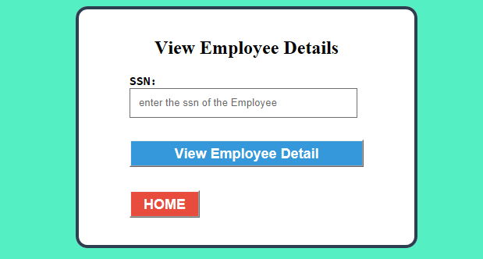

**Fig 4.5: EMPLOYEE VIEW PAGE**

The above figure shows employee view page. Here admin can retrieve employee details by entering ssn of employee.

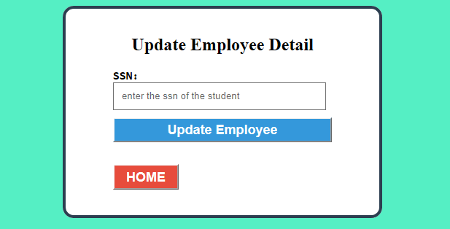

**Fig 4.6: EMPLOYEE UPDATE PAGE**

This above figure shows employee update page. Here if admin want to edit any of employee details he has to enter the ssn of employee.

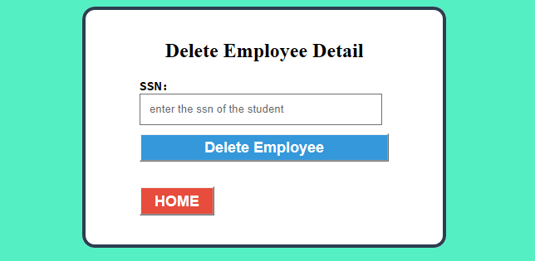

**Fig 4.7: EMPLOYEE DELETE PAGE**

This above figure shows employee delete page. If admin want to delete any of employee details he has to enter ssn of that employee.

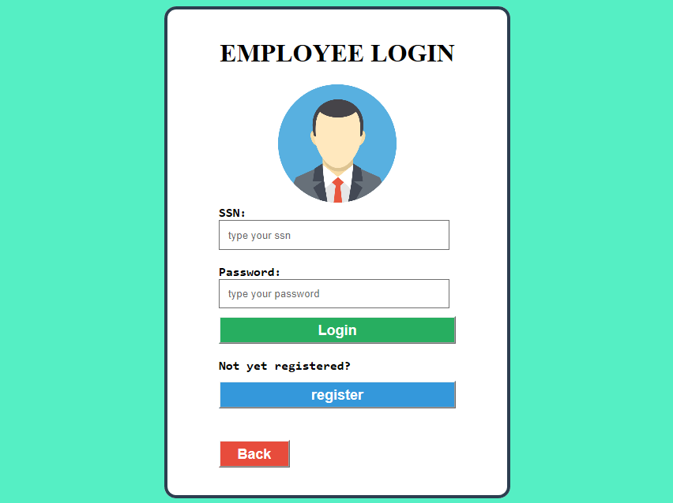

**Fig 4.8: EMPLOYEE LOGIN**

This above figure shows employee login page. After employee being sign up to system he can login to system by entering ssn and password.

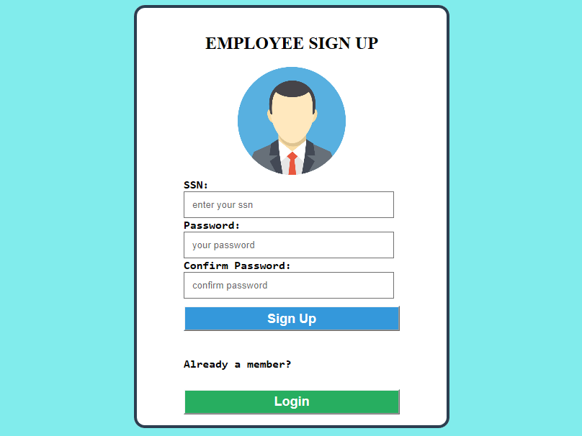

**Fig 4.9: EMPLOYEE SIGN UP PAGE**

The above figure shows sign up page for employee. For a new employee before login to system he or she should sign up to the system



**Fig 4.10: EMPLOYEE VIEW PAGE**

The above figure show employee view page where the employee will be entering ssn to view the details of employee.